Appetite for Freedom

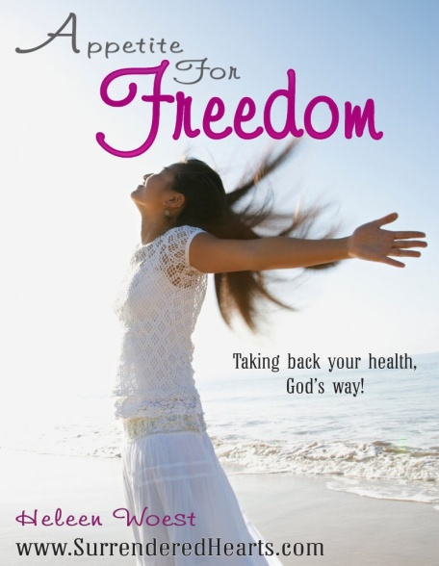
Come join women of all ages as we gather around God’s Word to find answers and break free from food related struggles such as overeating, stress eating, emotional eating, food addiction, binge eating and bulimia. You are not alone in this struggle. Please take your first step to freedom by reaching out to other women who know exactly what you’re dealing with.
This class is presented by [GROUP LEADER NAME] and we will be using a video driven Bible study: Appetite for Freedom. This curriculum has been successfully used by women around the globe to overcome food related struggles. It is based on the Bible and material by well-known Christian authors, counselors, and doctors.
Topics include: Dealing with the physical ramifications of food struggles such as food addiction and weight gain, finding the right food plan, overcoming temptation, dealing with issues such as perfectionism, people pleasing, and self-image, becoming consistent at exercise, finding healing through forgiveness, and most importantly falling in love with Jesus, the only One who can permanently change you and set you free!
PLACE:
[ADDRESS]
WHEN:
[DAY OF THE WEEK]
DATE:
[STATING AND ENDING DATE]
TIME:
[TIME OF DAY]
PRICE:
[PRICE FOR WORKBOOK AND CHILDCARE]
Childcare will be provided / Childcare will not be provided
CONTACT:
[CONTACT NAME AND PHONE NUMBER]

